**6 RIB GEN 5 WHIPPLE**

**MFP CRANK SUPPORT**

**Parts**

**&**

**Instructions**

**Parts:**

1. Main Plate 4. Double Post

Part A

1. Bearing Cap 5. Posts and Offset Leg

Part B

Part C

Part D

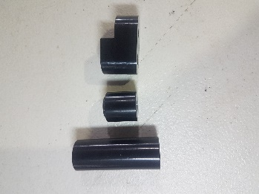

1. Snout Hub 6. Bolt kit

Bolt A M8x80MM

Bolts B M8x150mm

Bolt C M8x90mm

Bolt D M8x55mm

M6x20mm SHCS

Washer for Hub

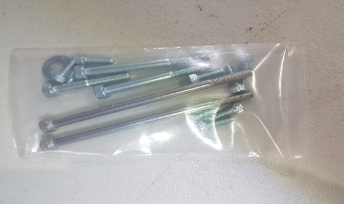

**Installation:**

Front View Above View

Side View Side View

Snout Hub into Bearing Cap

**Bolt B**

**Bolt B**

**Bolt D**

**Bolt A**

**Bolt C**

**Part B**

**Part A**

**Part C**

**Part D**

**Snout Hub**