2015 Outlaw Chin Spoiler (Does not fit with Performance Package Splitter)

CDC# 1511-7010-01

TEST FIT BEFORE PAINTING!!!
NOTE: This product is Injection Molded UV stable TPO. Install as is or if you prefer to paint to match, we recommend a Professional Automotive Paint Facility. Standard Fascia paint processes should be used.

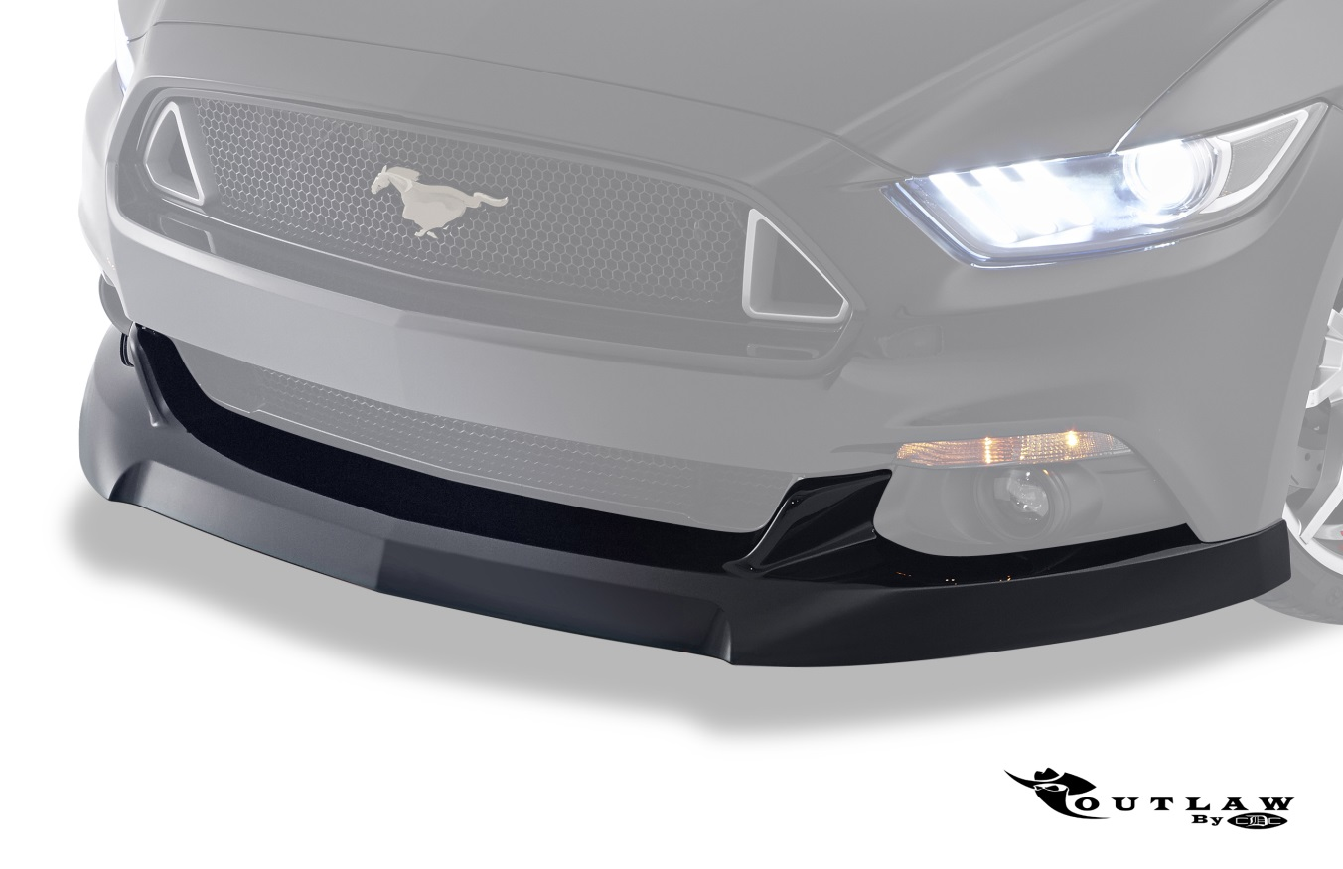

Note: READ instructions before starting installation!!!
Components: CDC Part#
- 1 - Outlaw Chin Spoiler 1511-2300-01
- 1 – Roll 3M ¼” & ½” Acrylic foam tape 950035
- 2 - Alcohol Packs 950006
- 2 – Adhesion Promoter Packs 950007
- 2 – Scrivets 181700

Tools Required:
- Panel Removal (fork tool)
- Razor knife/blade
Installation Procedure
- Prepare the front Fascia. Clean the surfaces shown in the pictures using the provided Alcohol Packs and allow time to dry. Apply the provided Adhesion Promoter to the same areas and allow time to dry.

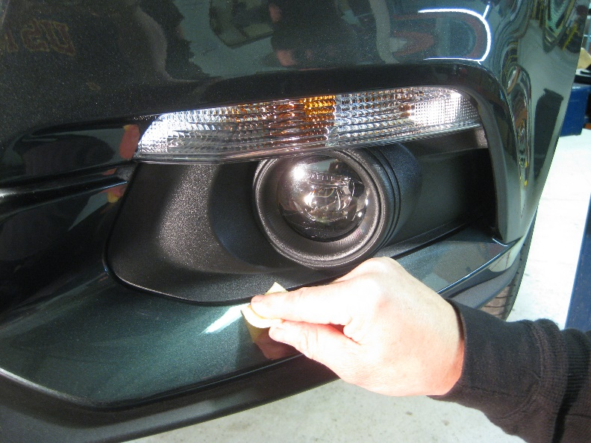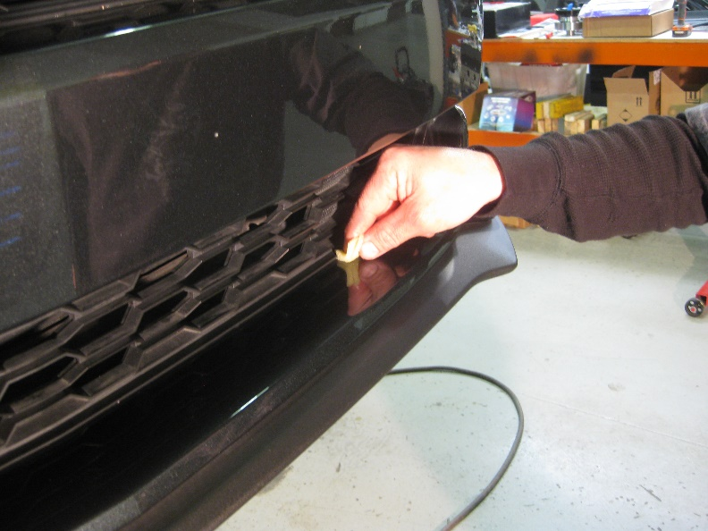

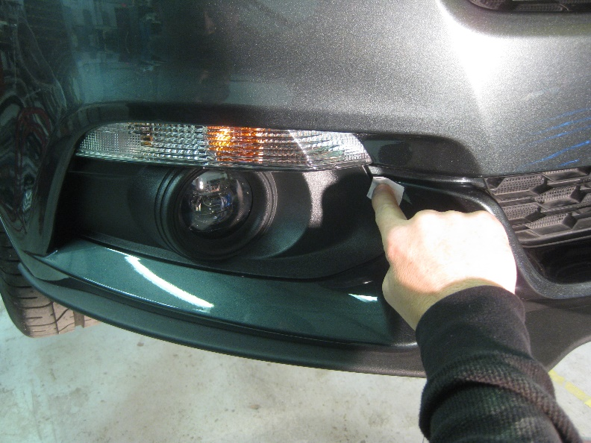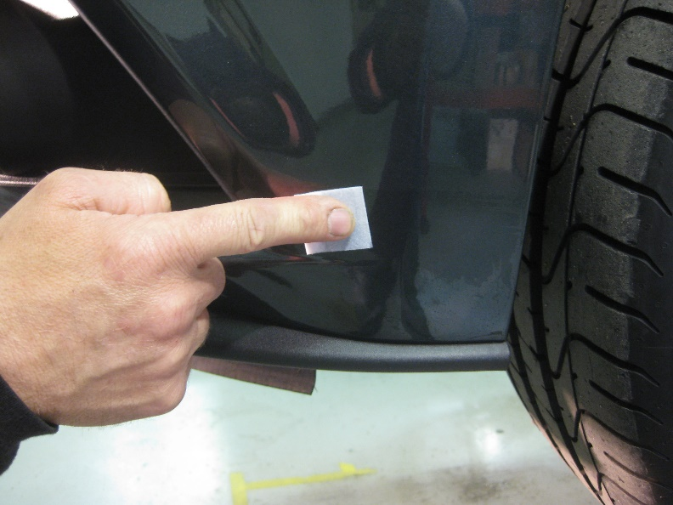

- Install the provided 3M Acrylic Foam Tape as shown in pictures below. Note: Apply tape about 1/8” away from fog light bezels and lower grille. Press tape firmly to activate the adhesive. Important: Create “pull tabs” with the red backing as shown.

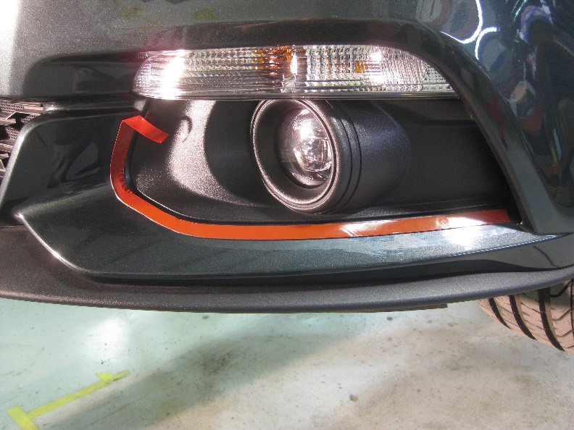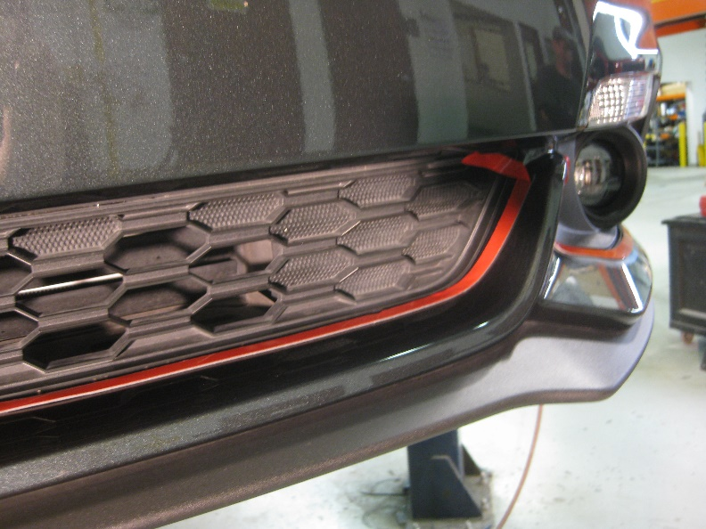
- Remove factory retainers from wheel liner area, place aside as these will be reused to attach the Chin Spoiler. NOTE: You may or may not be able to reuse these fasteners to secure your Outlaw Chin, depending which fastener was used during the assembly. We have included (2) Scrivets for your convenience, if needed.

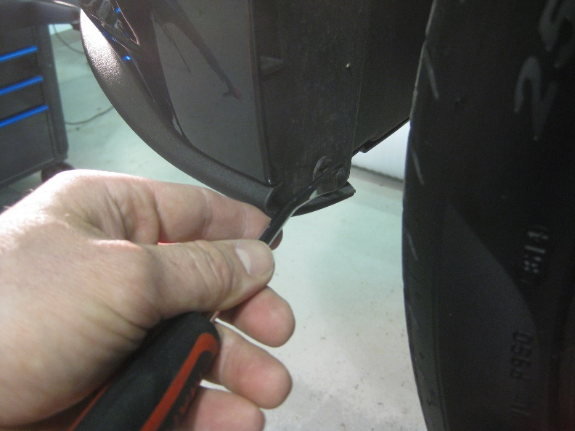

- Prepare the Tape areas on the back side of the Chin Spoiler as shown. Clean with provided Alcohol Pack, allow to dry. Apply the provided Adhesion Promoter and allow to dry.
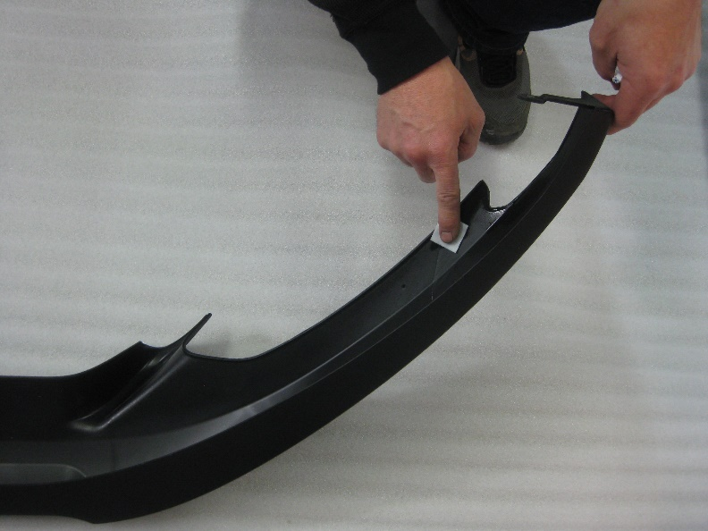

- Apply the ¼” 3M Acrylic Foam Tape as shown, leaving “pull tabs” with the red backing.

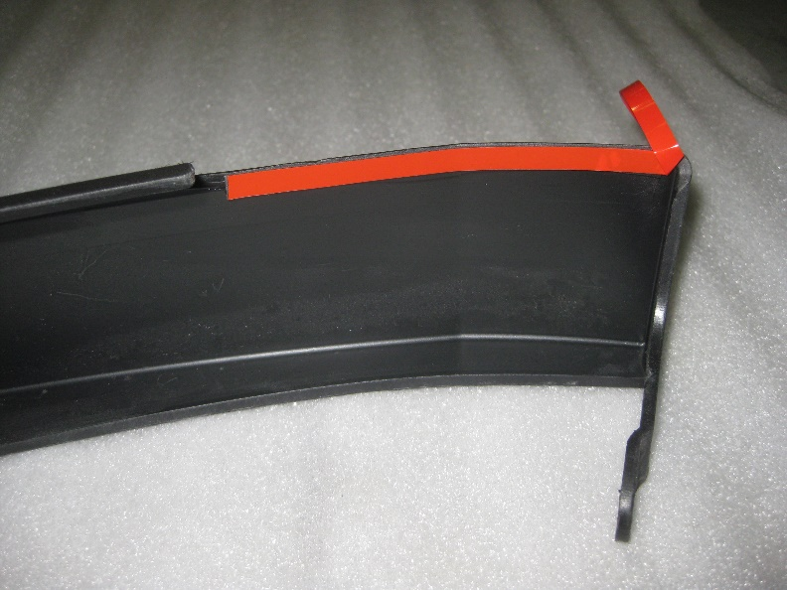
- Install Chin Spoiler. Place Chin Spoiler on the Fascia, making sure the “pull tabs” are all accessible. Peel red backing and press Chin Spoiler firmly to activate adhesive.

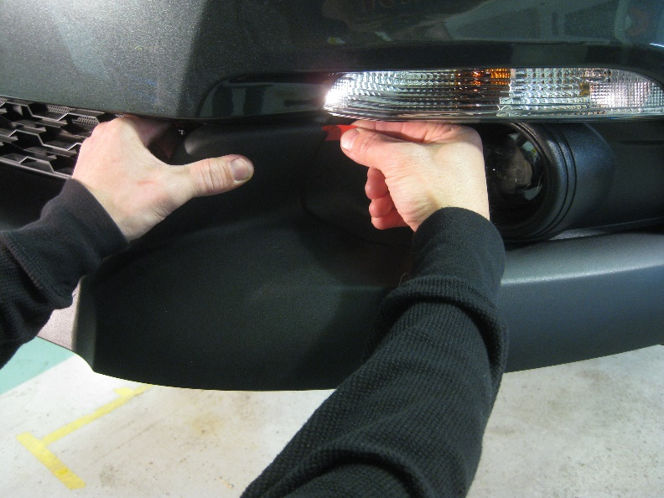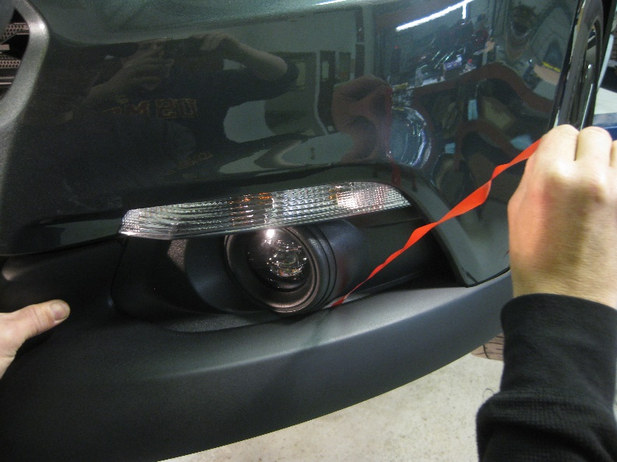

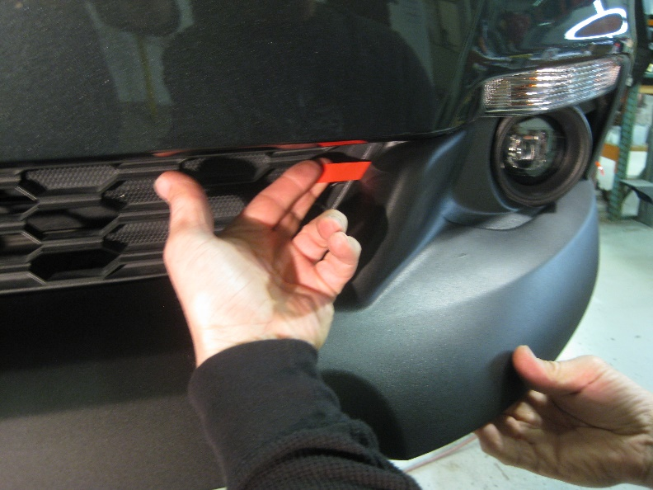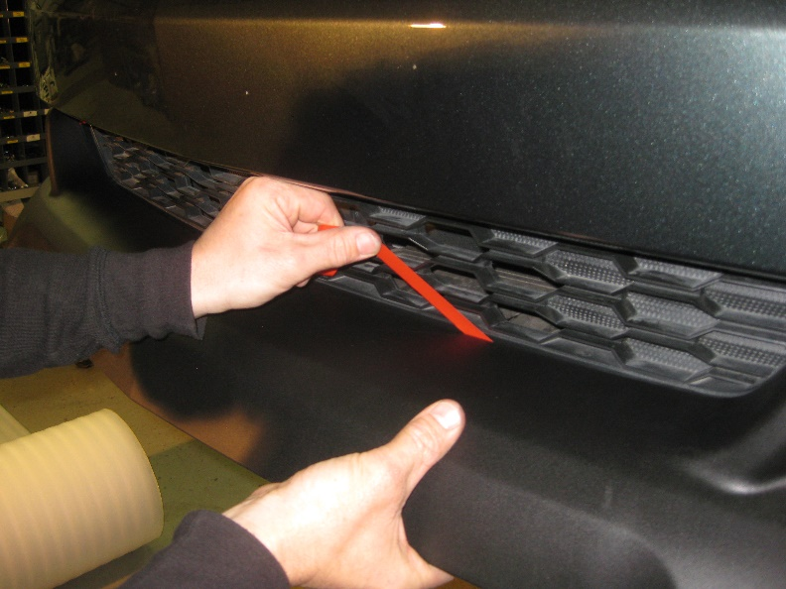

- Reinstall the factory retainers removed in step #3, or use the provided Scrivets.

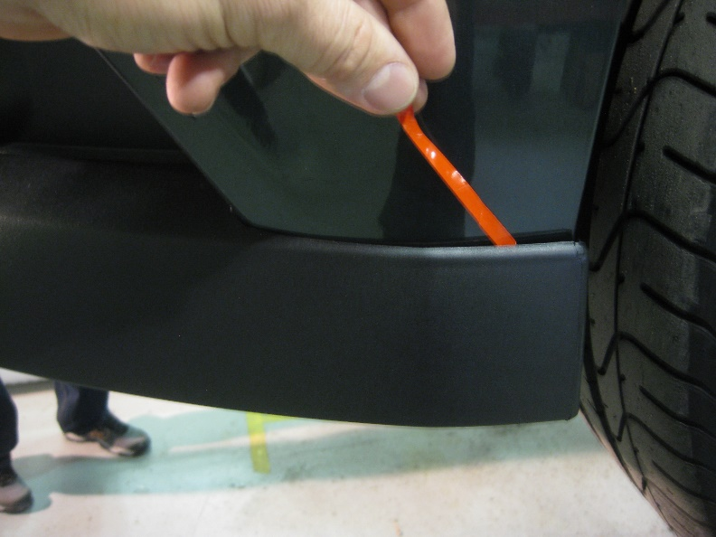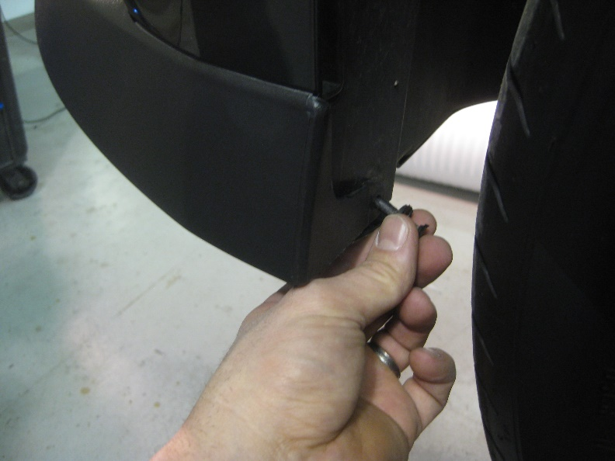

Thank you for choosing Classic Design Concepts for your restyling needs. If you have any questions or concerns regarding installation, please contact Tech@CDCdetroit.com
or call 866-624-7997.

